**Shell Scripting**

**Shell**

At its base, a **shell** is simply a **macro processor** that **executes commands**. The term macro processor means functionality where text and symbols are expanded to create larger expressions

A Unix shell is both a command interpreter and a programming language. As a command interpreter, the shell provides the user interface to the rich set of gnu utilities. The programming language features allow these utilities to be combined. Files containing commands can be created, and become commands themselves.

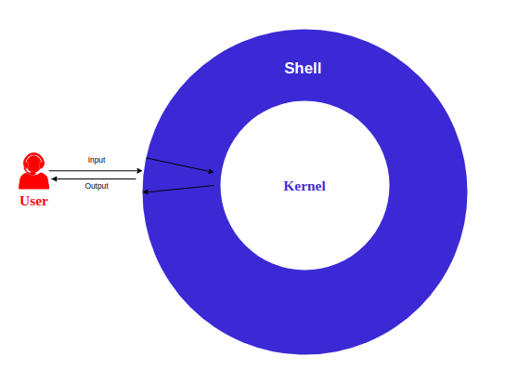

**Q:** What is Shell?  
**A:** The shell is the **command interpreter** in an operating system such as Unix or GNU/Linux, it is a program that executes other programs. It provides a computer user an interface to the Unix/GNU Linux system so that the user can run different commands or utilities/tools with some input data.

 - Interview Q&A

**Bash**

**Bash** is the **shell**, or command language interpreter, for the GNU operating system. The name is an acronym for the ‘**B**ourne-**A**gain **SH**ell’. First used by Stephen Bourne, the author of the direct ancestor of the current Unix shell sh.

While the GNU operating system provides other shells, including a version of csh, Bash is the **default shell**. Like other gnu software, Bash is quite portable. It currently runs on nearly every version of Unix and a few other operating systems − independently-supported ports exist for ms-dos, os/2, and Windows platforms.



**The Bash prompt(teşvik edici)**

The Bash prompt can do much more than displaying such simple information as your user name, the name of your machine and some indication about the present working directory. We can add other information such as the current date and time, number of connected users etc.

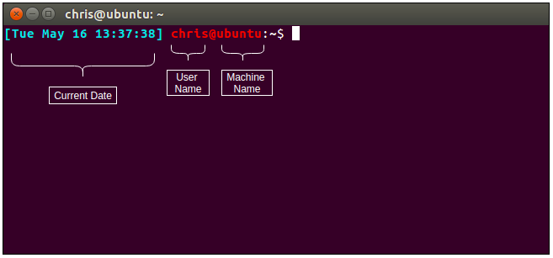

We will some play on Bash prompt. But before change prompts properties we will save our current prompt in another environment variable:

[walter@onemachine jerry]$ MYPROMPT=$PS1

[walter@onemachine jerry]$ echo $MYPROMPT

=> [\u@\h \W]\$

[walter@onemachine jerry]$

Video :

<https://youtu.be/_kSCpNqKJbM>

Some Examples

In order to understand these prompts and the escape sequences used, we refer to the Bash Info or man pages.

* export PS1="[\t \j] "
  + Displays time of day and number of running jobs
* export PS1="[\d][\u@\h \w] : "
  + Displays date, user name, host name and current working directory. Note that \W displays only base names of the present working directory.
* export PS1="{!} "
  + Displays history number for each command.
* export PS1="[\033[1;35m]\u@\h[\033[0m] "
  + Displays user@host in pink.
* export PS1="[\033[7;34m]\u@\h \w [\033[0m] "
  + White characters on a blue background.
* export PS1="[\033[3;35m]\u@\h \w [\033[0m]\a"
  + Pink prompt in a lighter font that alerts you when your commands have finished.

If you want, prompts can execute shell scripts and behave differently under different conditions. You can even have the prompt play a tune every time you issue a command.

**Shell Scripts**

A shell script is a text file containing shell commands. Scripting allows for an automatic commands execution that would otherwise be executed interactively one-by-one.

The UNIX shell program interprets user commands, which are either directly entered by the user, or which can be read from a file called the shell script or shell program. Shell scripts are interpreted, not compiled(yorumlanır, derlenmez). The shell reads commands from the script line per line and searches for those commands on the system, while a compiler converts a program into a machine-readable form, an executable file – which may then be used in a shell script.

A shell script may be made executable by using the **chmod** command to turn on the **execute** bit. When Bash finds such a file while searching the PATH for a command, it spawns a sub-shell to execute it.

Bash scripts often begin with

#! /bin/bash

(assuming that Bash has been installed in /bin), since this ensures that Bash will be used to interpret the script, even if it is executed under another shell.

**Shell types**

Just like people know different languages and dialects, your UNIX system will usually offer a variety of shell types:

**sh** or Bourne Shell: the original shell still used on UNIX systems and in UNIX-related environments. This is the **basic shell**, a small program with few features. While this is not the standard shell, it is still available on every Linux system for compatibility with UNIX programs.

**bash** or **Bourne Again shell** : the **standard GNU shell**, intuitive and flexible. Probably most advisable for beginning users while being at the same time a powerful tool for the advanced and professional user. On Linux, bash is the standard shell for common users. This shell is a so-called superset of the Bourne shell, a set of add-ons and plug-ins. This means that the Bourne Again shell is compatible with the Bourne shell: commands that work in sh, also work in bash. However, the reverse is not always the case.

**csh** or **C shell** : the syntax of this shell resembles that of the **C programming language**. Sometimes asked for by programmers.

**tcsh** or **TENEX C shell** : a superset of the common C shell, enhancing user-friendliness and speed. That is why some also call it the Turbo C shell.

**ksh** or the **Korn shell**: sometimes appreciated by people with a UNIX background. A superset of the Bourne shell; with standard configuration a nightmare for beginning users.

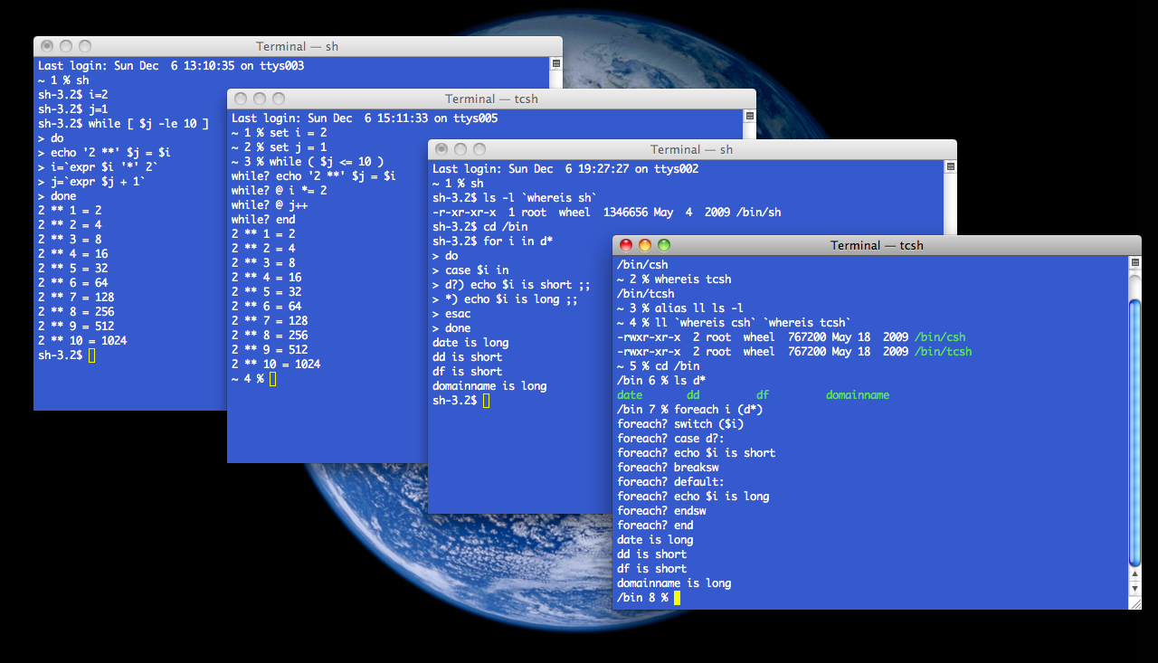**Shell Types**

The file /etc/shells gives an overview of known shells on a Linux system:

cat /etc/shells

/bin/bash

/bin/sh

/bin/tcsh

/bin/csh

Your default shell is set in the /etc/passwd file.

To switch from one shell to another, just enter the name of the new shell in the active terminal. The system finds the directory where the name occurs using the PATH settings, and since a shell is an executable file (program), the current shell activates it and it gets executed

**Finding Bash**

The easiest way is to use which command:

$ which bash

To find the bash run this command from the root dir:

$ find ./ name_of_your_bash

Other locations to check:

ls −l /bin/bash

ls −l /sbin/bash

ls −l /usr/local/bin/bash

ls −l /usr/bin/bash

ls −l /usr/sbin/bash

ls −l /usr/local/sbin/bash

To define your script’s interpreter as Bash, first locate a full path to its executable binary using which command, prefix it with a shebang #! and insert it as the first line of your script. There are various other techniques on how to define a shell interpreter, but this is a solid start.

Open up you favorite text editor and create file called hello_world.sh. Insert the following lines to a file:

**Note:** Every bash shell script in starts with shebang:"***#!***" which is not read as a comment. First line is also a place where you put your interpreter which is in this case: /bin/bash.

**Script File Execution**

cute bash scripts is to call bash interpreter explicitly eg. $ bash date.sh, hence executing the script without the need to make the shell script executable and without declaring shebang directly within a shell script. By calling bash executable binary explicitly, the content of our file date.sh is loaded and interpreted as Bash Shell Script.

create a new file named hello-world.sh containing the below code:

#!/bin/bash

echo “Hello World”

Once ready, make your script executable with the chmod command and execute it using relative path ./hello-world.sh:

$ chmod +x hello-world.sh

$ linuxconfig.org:~$ ./hello-world.sh

**echo**

Here is our first bash shell script example; traditional hello world script:

#!/bin/bash

# declare STRING variable

STRING="Hello World"

#print variable on a screen

echo $STRING

Navigate to a directory where your hello_world.sh is located and make the file executable:

$ chmod +x hello_world.sh

Make bash shell script executable. Now you are ready to execute your first bash script:

$ ./hello_world.sh  
Hello World!

Let's request user's age then print his age:

#! /bin/bash

clear

echo "Enter your age"

read st1

echo "Your age: " $st1

run:

$ ./your_age.sh

Output:

Enter your age

29 (User will enter an age)

Your age: 29

**Variables**

You can use variables as in any programming language. There are no data types. A variable in bash can contain a number, a character, a string of characters. You have no need to declare a variable, just assigning a value to its reference will create it.

Sample: Writing "James" using variables:

#!/bin/bash

NAME=”James”

echo $NAME

echo "$NAME"

echo "${NAME}!"

**String Quotes**

* Enclosing characters in single quotes (‘ **'** ’) preserves the literal value of each character within the quotes.
* Enclosing characters in double quotes (‘ **"** ’) preserves the literal value of all characters within the quotes, with the exception of ‘$’, ‘`’, ‘\’

NAME="John"

echo "Hi $NAME" #=> Hi John

echo 'Hi $NAME' #=> Hi $NAME

**Brace Expansion**

Brace expansion is a mechanism by which arbitrary strings may be generated.

echo {A,B}.js

{A,B} Same as A B

{A,B}.js Same as A.js B.js

{1..5} Same as 1 2 3 4 5

**String Lists**

The brace expansion is only performed if the given string list is really a list of strings:

$ echo {I,want,my,money,back}

I want my money back

$ echo _{I,want,my,money,back}

_I _want _my _money _back

$ echo {I,want,my,money,back}_

I_ want_ my_ money_ back_

$ echo _{I,want,my,money,back}-

_I- _want- _my- _money- _back-

**Comments**

* Bash ignores everything written on the line after the hash mark (#). The only exception to this rule is when the first line on the script starts with the #! characters. Comments can be added at the beginning of the line or inline with other codes.

#!/bin/bash

echo "hello"

# date

pwd # This is an inline comment

# ls

* Unlike most of the programming languages, Bash doesn’t support multiline comments. But, we can use HereDoc for this. It is a type of redirection that allows us to pass multiple lines of input to a command. If the HereDoc block is not redirected to a command, it can serve as a multiline comments placeholder.

cat << EOF

Welcome to the Linux Lessons.

This lesson is about the shell scripting

EOF

<< 'multiline-comment'

pwd

ls

Everything inside the

HereDoc body is

a multiline comment

multiline-comment

**Comparisons**

**Numeric and String Comparisons**

Using bash shell comparisons, we can compare strings ( words, sentences ) or integer numbers whether raw or as variables. Note that **[[** is actually a command/program that returns either 0 (true) or 1 (false). The following table lists rudimentary comparison operators for both numbers and strings:

Shell comparison example:

[ 100 -eq 100 ]

echo $? # 0

[ “GNU” = “UNIX” ]

| **Command** | **Operation** |
| --- | --- |
| -lt | < |
| -gt | > |
| -le | <= |
| -ge | >= |
| -eq | == |
| -ne | != |

echo $? # 1

File Conditions

We can check files' conditions:

[[ -e FILE ]] Exists

[[ -r FILE ]] Readable

[[ -d FILE ]] Directory

[[ -w FILE ]] Writable

**Conditionals**

Conditionals let you decide whether to perform an action or not, this decision is taken by evaluating an expression.

if .. then example:

#!/bin/bash

if [ "foo" = "foo" ]; then

echo expression evaluated as true

fi

if .. then…else example:

#! /bin/bash

clear

echo "enter a number"

read st1

if (( $st1 == 5 ))

then

echo "You entered five!"

fi

# -eq -gt -lt -ge -le -a -o

if [ $st1 -eq 5 ]

then

echo equal to five

elif (( $st1 < 5 ))

then

echo "less than five"

else

echo "more than five"

fi

**Loops**

**for, while and until**

In this part, you’ll find for, while and until loops.

The for loop is a little bit different from other programming languages. Basically, it lets you iterate over a series of ‘words’ within a string.

The while executes a piece of code if the control expression is true, and only stops when it is false (or an explicit break is found within the executed code.

The until the loop is almost equal to the while loop, except that the code is executed while the control expression evaluates to false

**For:**

#!/bin/bash

for i in $( ls ); do

echo item: $i

done

for service in S3 EC2 Lambda Glacier CloudFront Kinesis

do

echo "Amazon Service: $service"

done

**While:**

#!/bin/bash

COUNTER=0

while [ $COUNTER -lt 10 ]; do

echo The counter is $COUNTER

let COUNTER=COUNTER+1

done

Until sample

#!/bin/bash

COUNTER=20

until [ $COUNTER -lt 10 ]; do

echo COUNTER $COUNTER

let COUNTER-=1

done

**Functions**

As in almost any programming language, you can use functions to group pieces of code in a more logical way or practice the divine art of recursion(özyineleme).

Declaring a function is just a matter of writing function my_func { my_code }.

Calling a function is just like calling another program, you just write its name.

**Functions sample:**

#!/bin/bash

function quit {

exit

}

function hello {

echo Hello!

}

hello

quit

echo foo

**Case**

Each case statement starts with the case keyword followed by the case expression and the in keyword. The statement ends with the esac keyword. You can use multiple patterns separated by the | operator. The ) operator terminates a pattern list.

case EXPRESSION in

PATTERN_1)

STATEMENTS

;;

PATTERN_2)

STATEMENTS

;;

PATTERN_N)

STATEMENTS

;;

*)

STATEMENTS

;;

esac

**Case and Function**

#!/bin/bash

inputs(){

read -p "Enter first integer: " int1

read -p "Enter second integer: " int2

}

exitPrompt(){

read -p "Do you wish to continue? [y]es or [n]o: " ans

if (( $ans == "n"))

then

echo "Exiting the script. Have a nice day!"

sleep 2

exit

else

continue

fi

}

while(true)

do

clear

printf "Choose from the following operations: \n"

printf "[a]Addition\n[b]Subtraction\n[c]Multiplication\n[d]Division\n"

printf "################################\n"

read -p "Your choice: " choice

case $choice in

[aA])

inputs

res=$((int1+int2))

;;

[bB])

inputs

res=$((int1-int2))

;;

[cC])

inputs

res=$((int1*int2))

;;

[dD])

inputs

res=$((int1/int2))

;;

*)

res=0

echo "wrong choice!"

esac

echo "The result is: " $res

exitPrompt

done

Compelemntary Video :

<https://youtu.be/eiBVlxxu3so>